CHAPTER - 3
Lenskart E-Commerce Database Management System

3.1 Introduction
Lenskart is one of India's leading eyewear retailers, offering spectacles, sunglasses, contact lenses, and eye-care products through online and offline channels. The Lenskart Analysis System is designed to manage customer information, products, prescriptions, orders, payments, deliveries, reviews, brands, suppliers, and store operations. The database design ensures data consistency and supports efficient business analysis.

3.2 ER Diagram
The Entity Relationship (ER) Diagram represents the logical structure of the Lenskart Analysis Database. It illustrates the entities, attributes, and relationships involved in the system.

Entity | Description
Customer | Stores customer information
Product | Stores eyewear product details
Category | Classifies products
Brand | Stores brand information
Supplier | Stores supplier information
Prescription | Stores eye prescription details
Cart | Stores shopping cart information
Order | Stores order information
Order Item | Stores products within orders
Payment | Stores payment details
Delivery | Stores delivery information
Review | Stores customer reviews
Store | Stores store information

i. Customer ii. Category

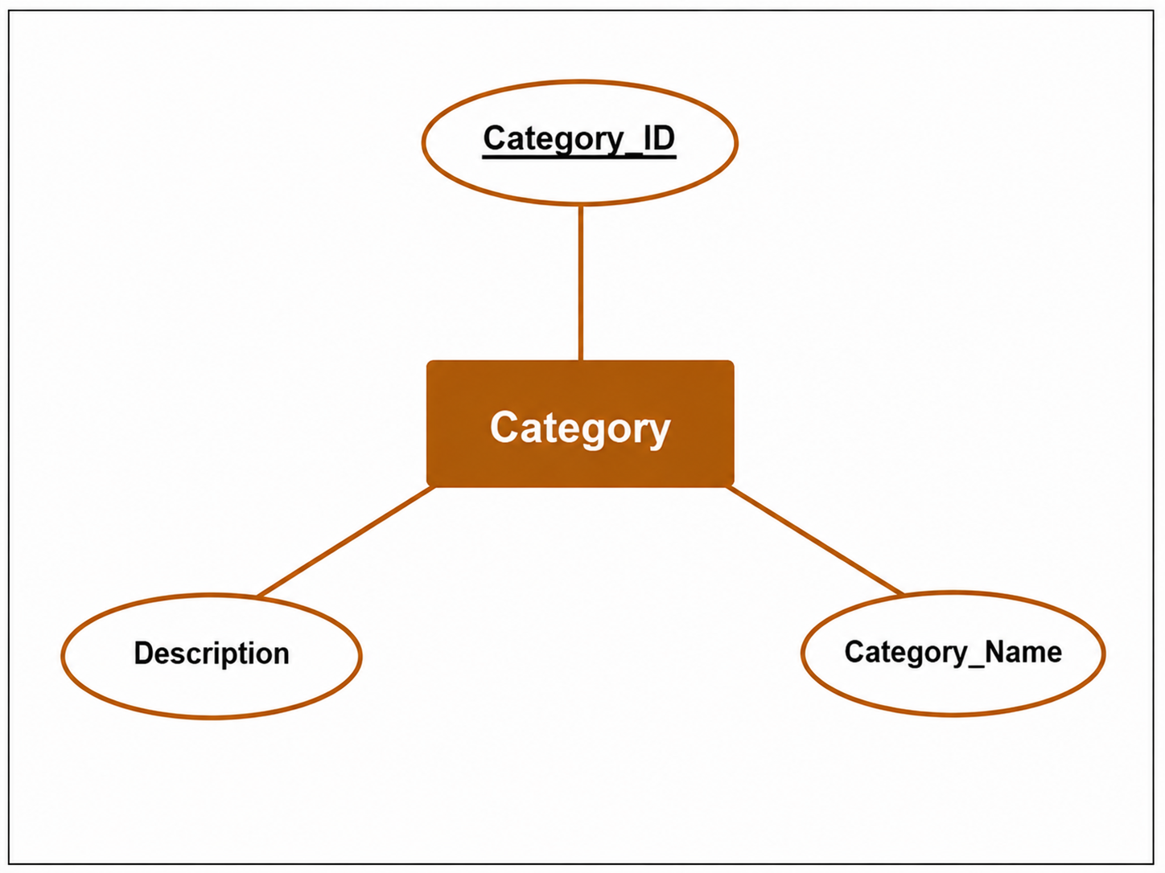
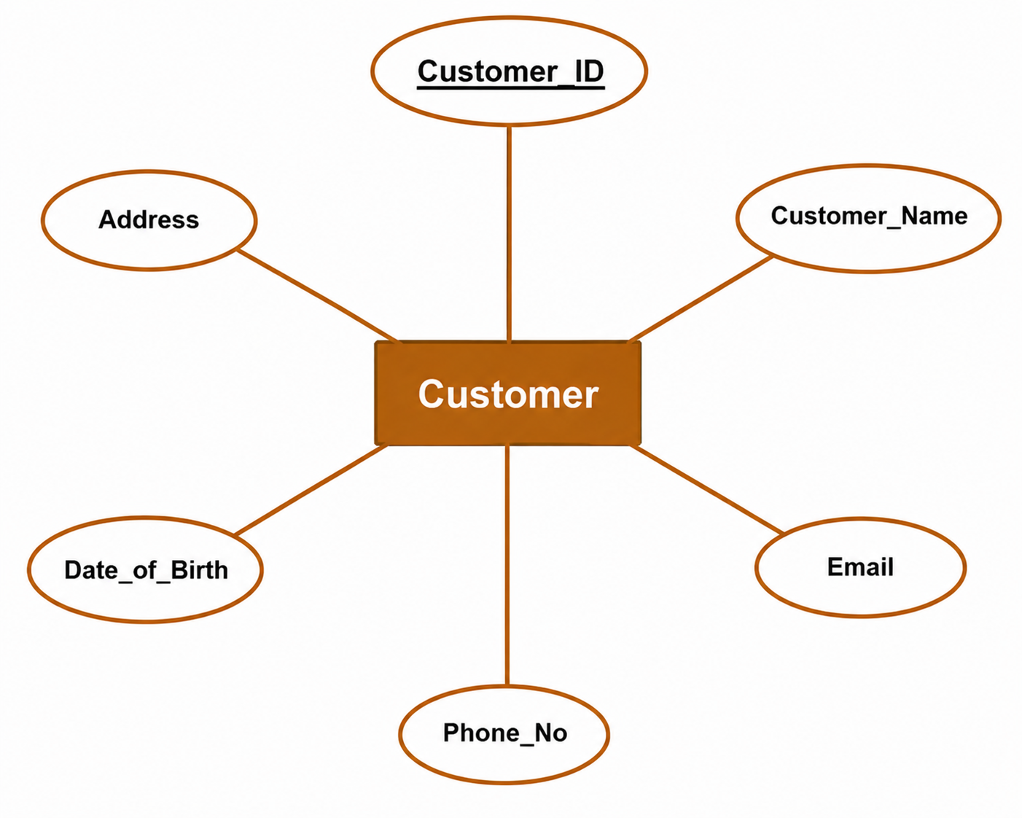

iii. Brand iv. Product

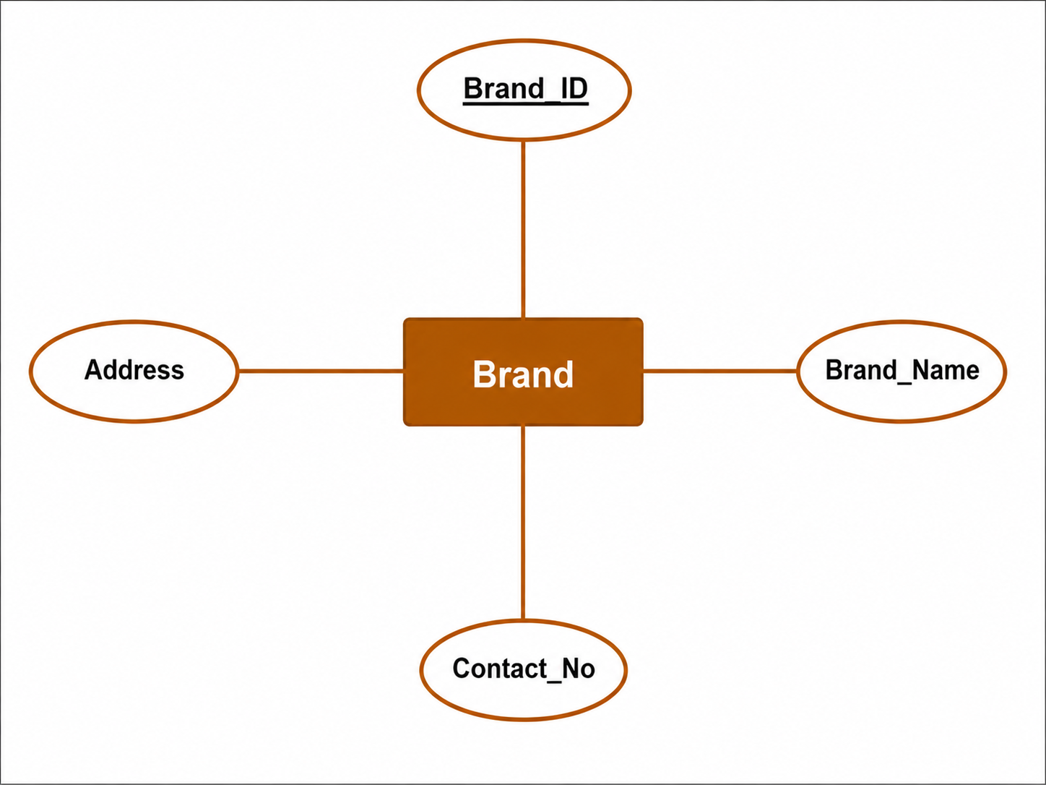
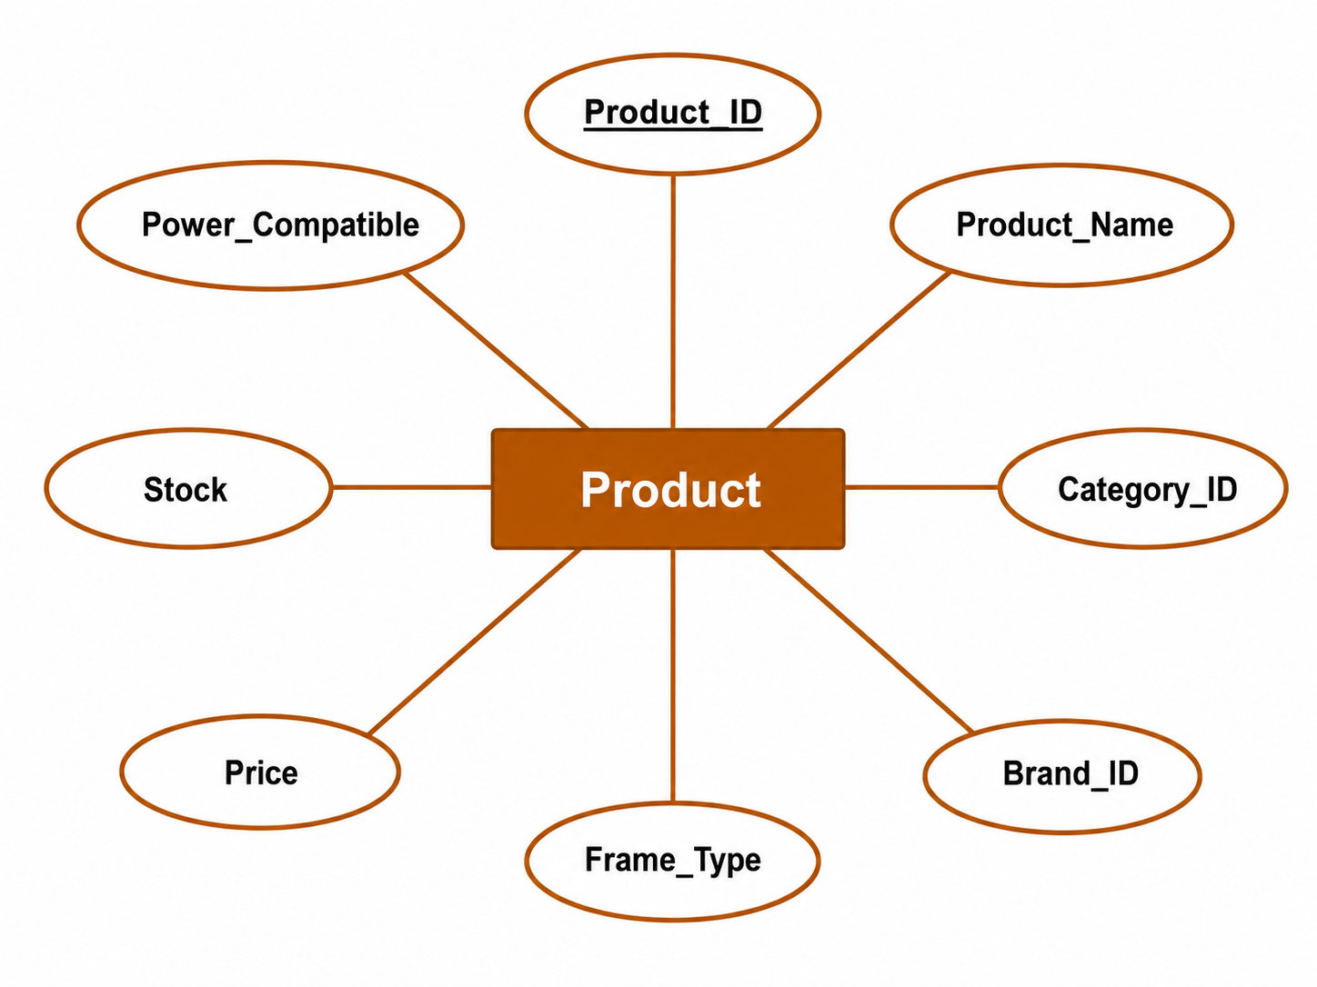

v. Prescription vi. Cart
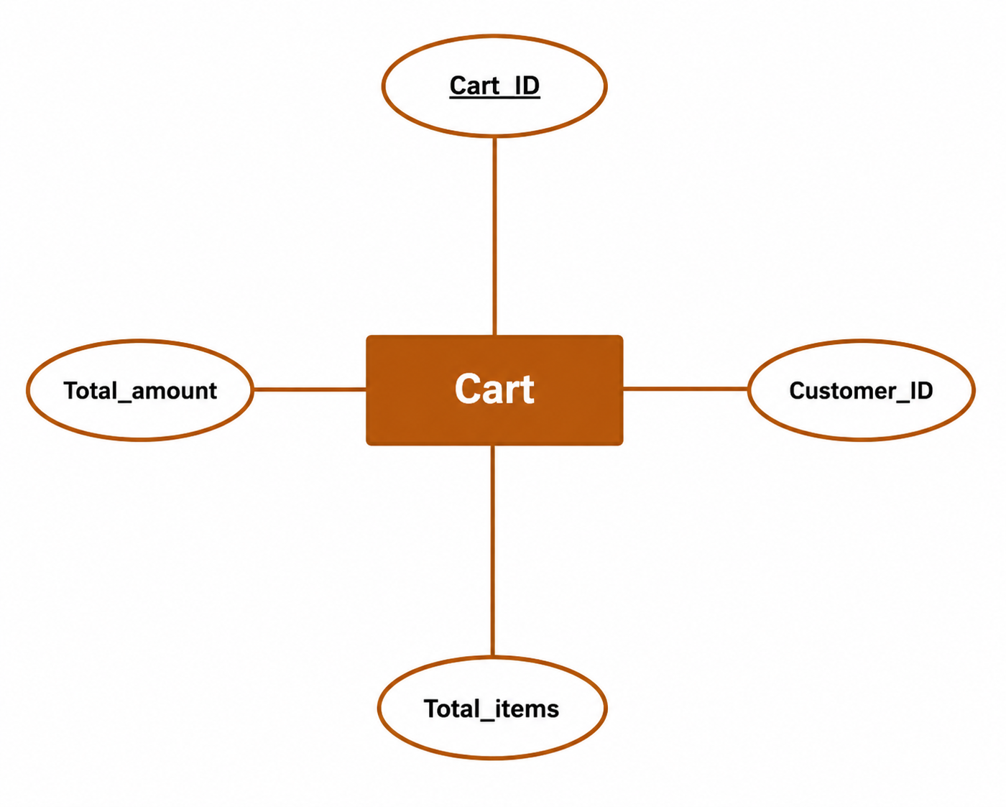
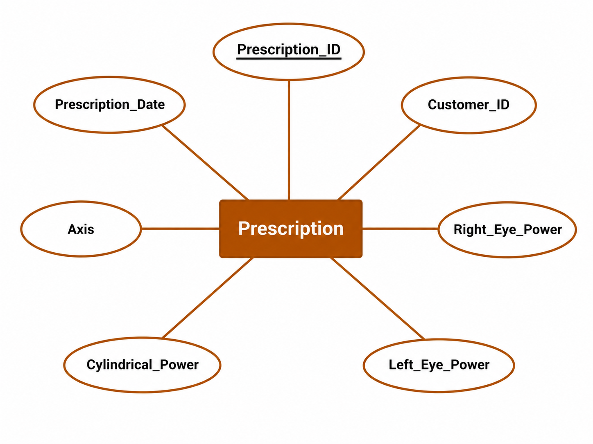

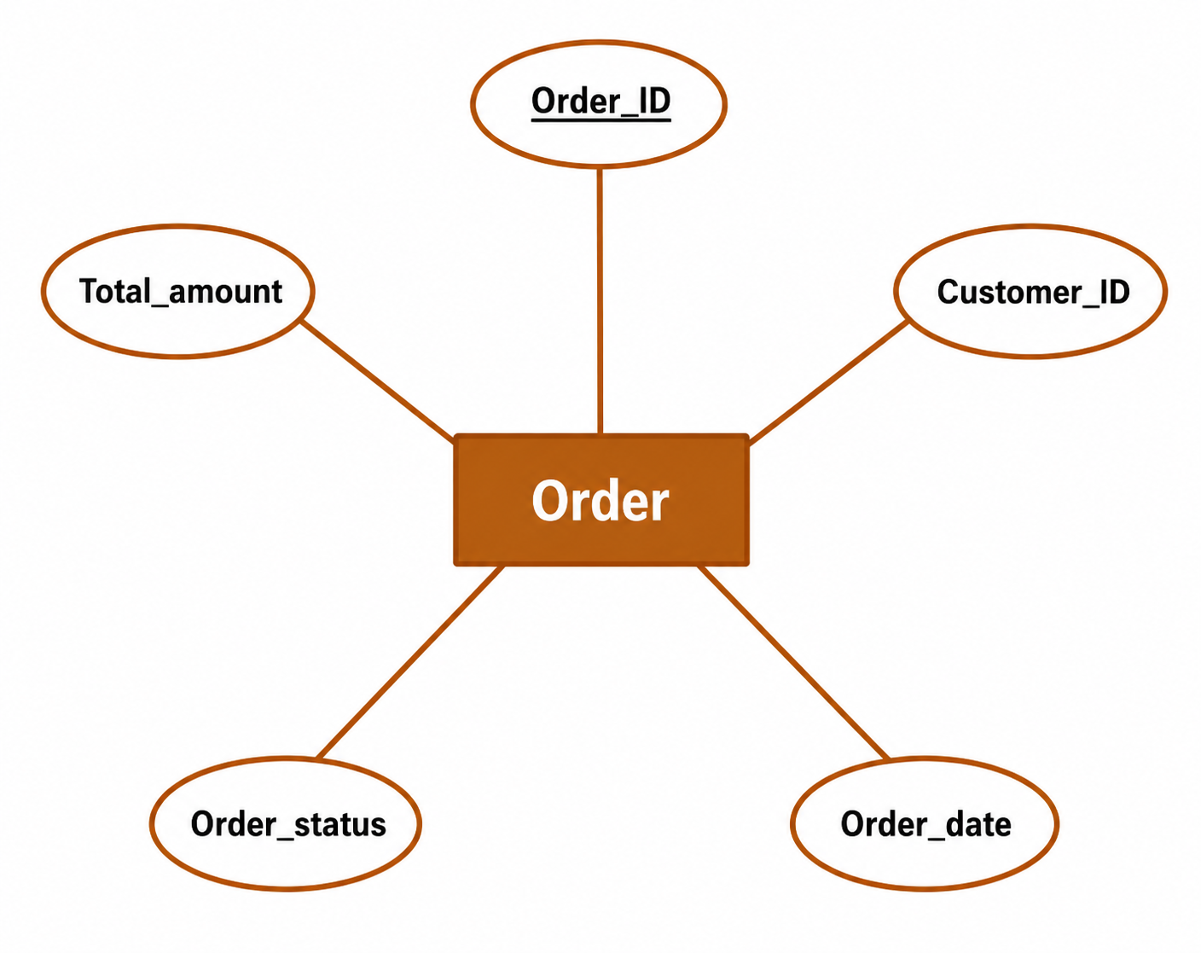
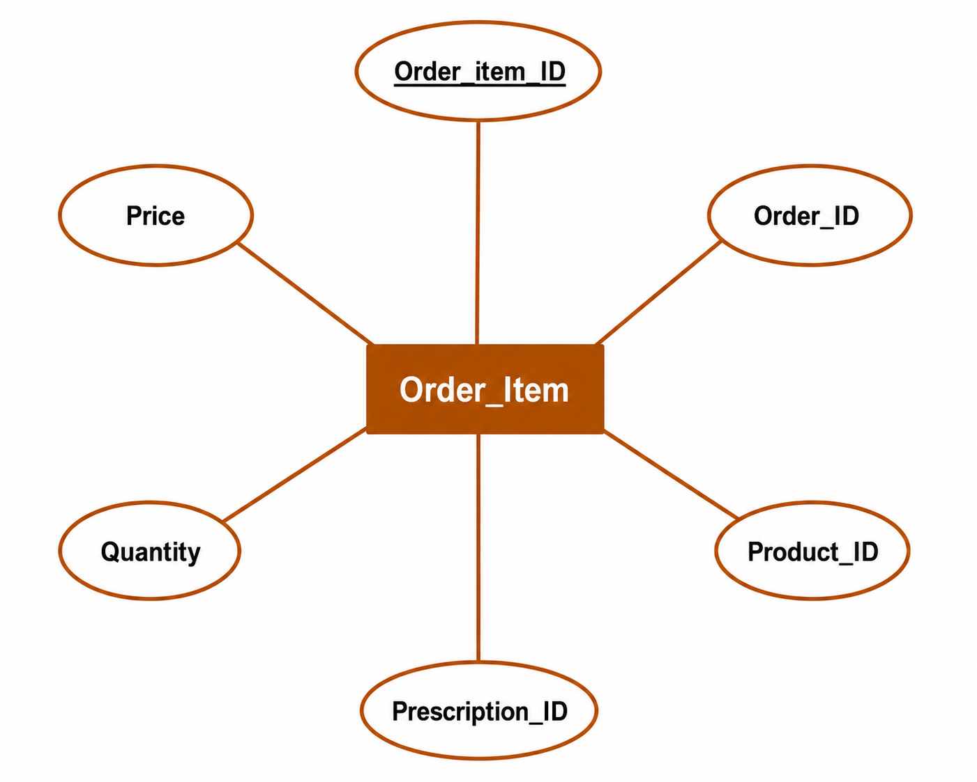
vii. Order viii. Order Item (weak Entity)

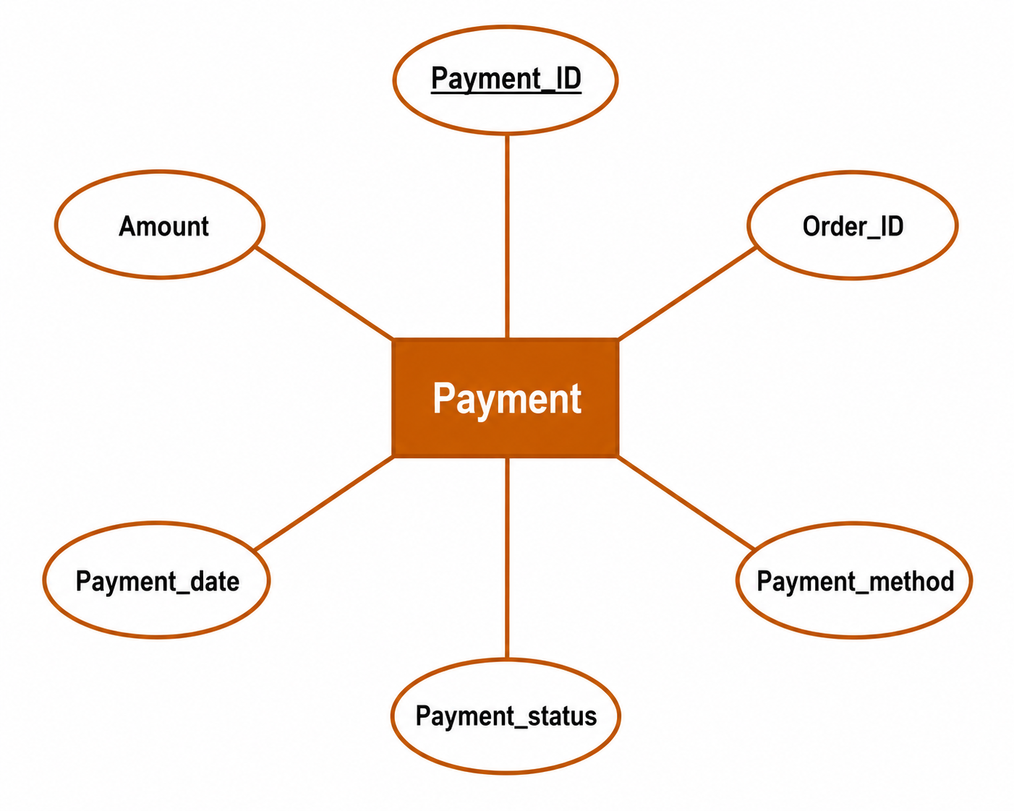
xi. Payment x. Review
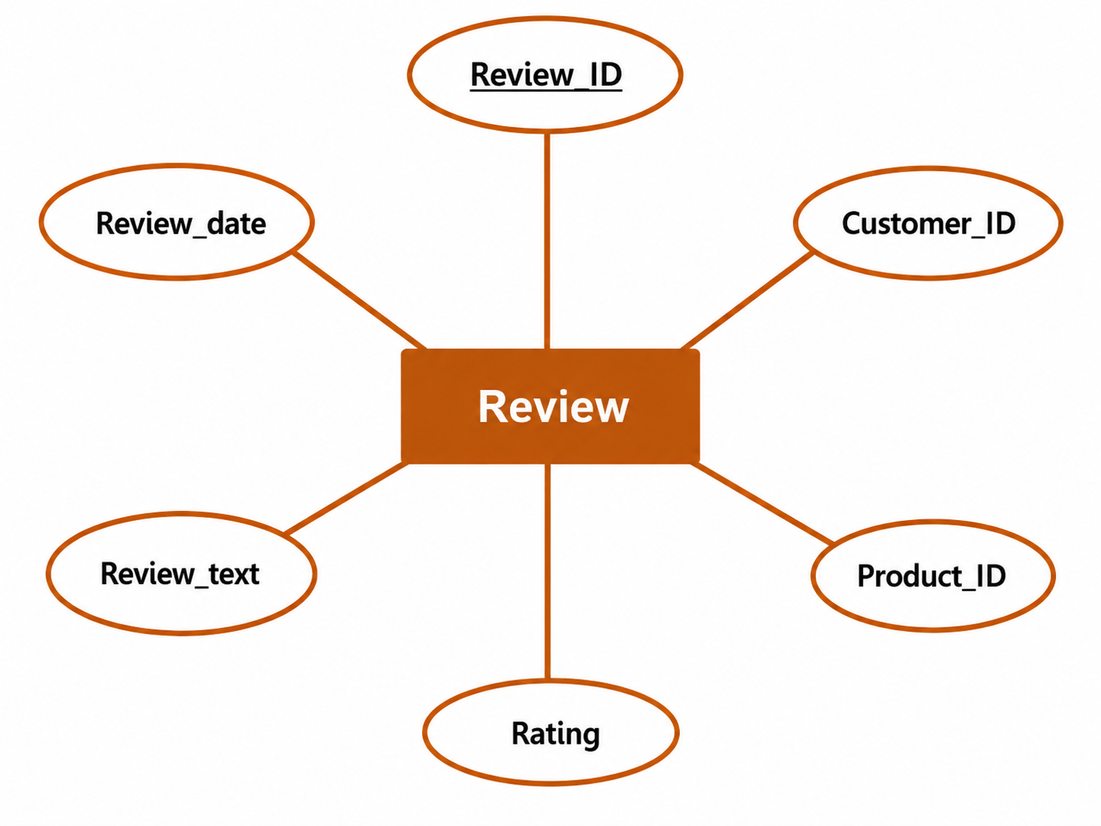

xi. Delivery x. Store
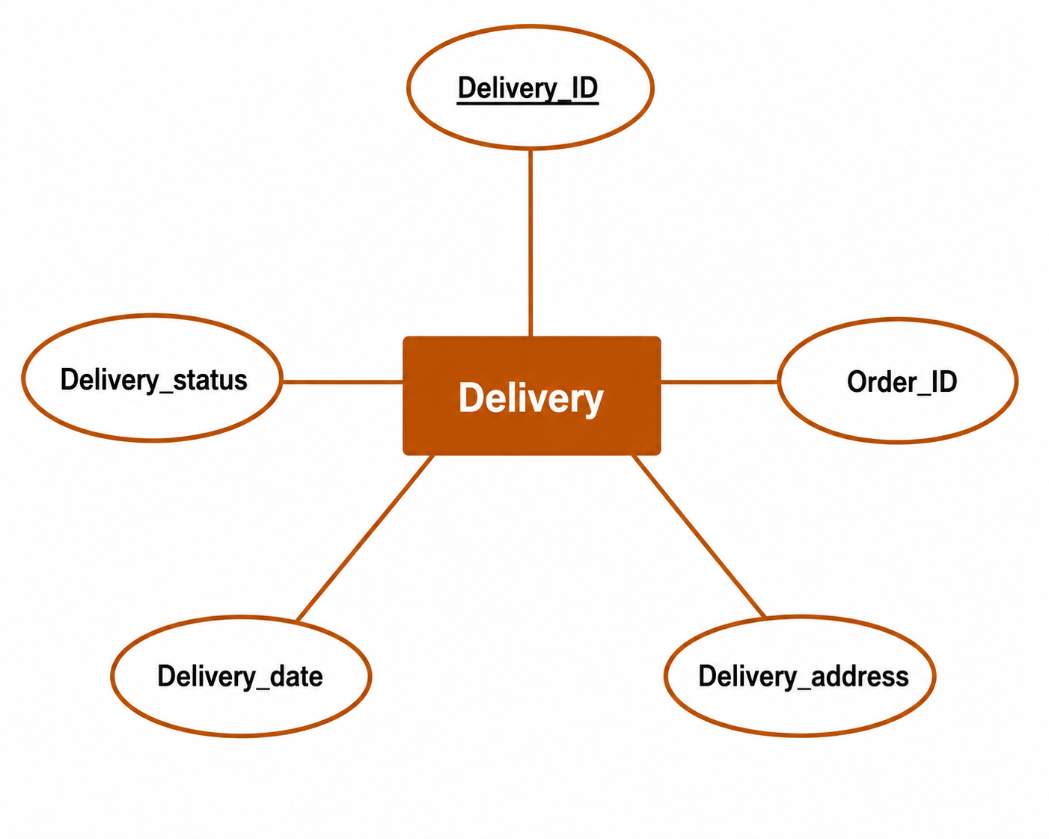
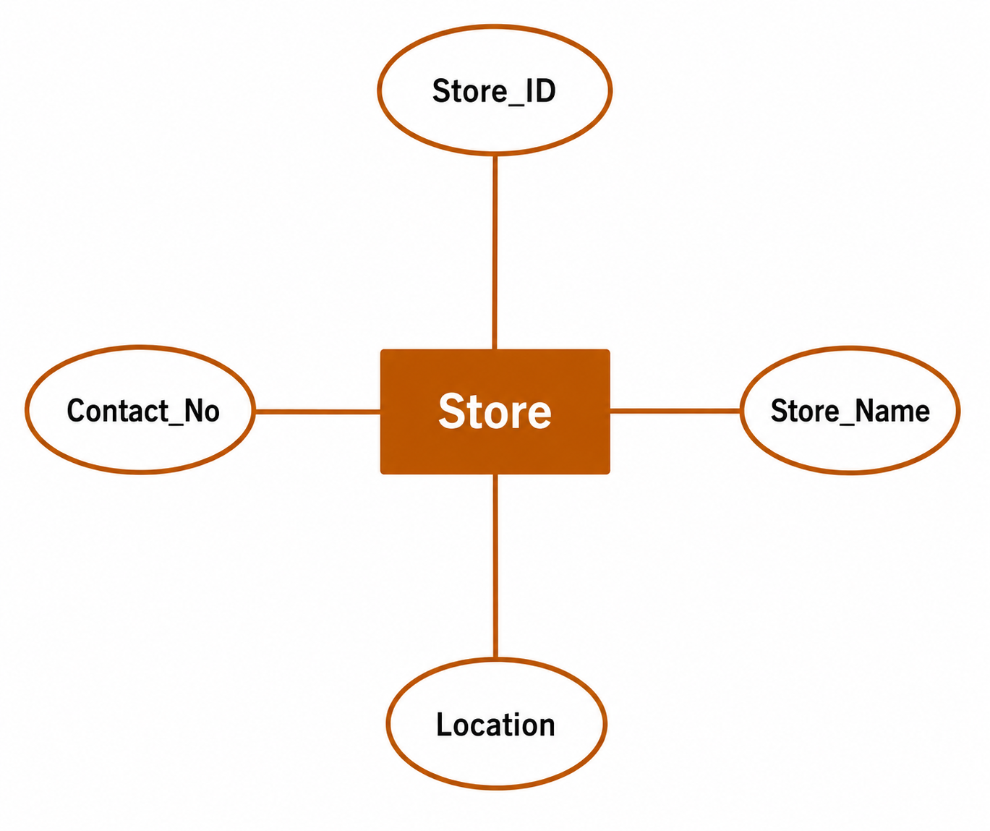

3.3 Relational Schema
The relational schema shows the tables, attributes, primary keys, and foreign-key relationships derived from the ER model.

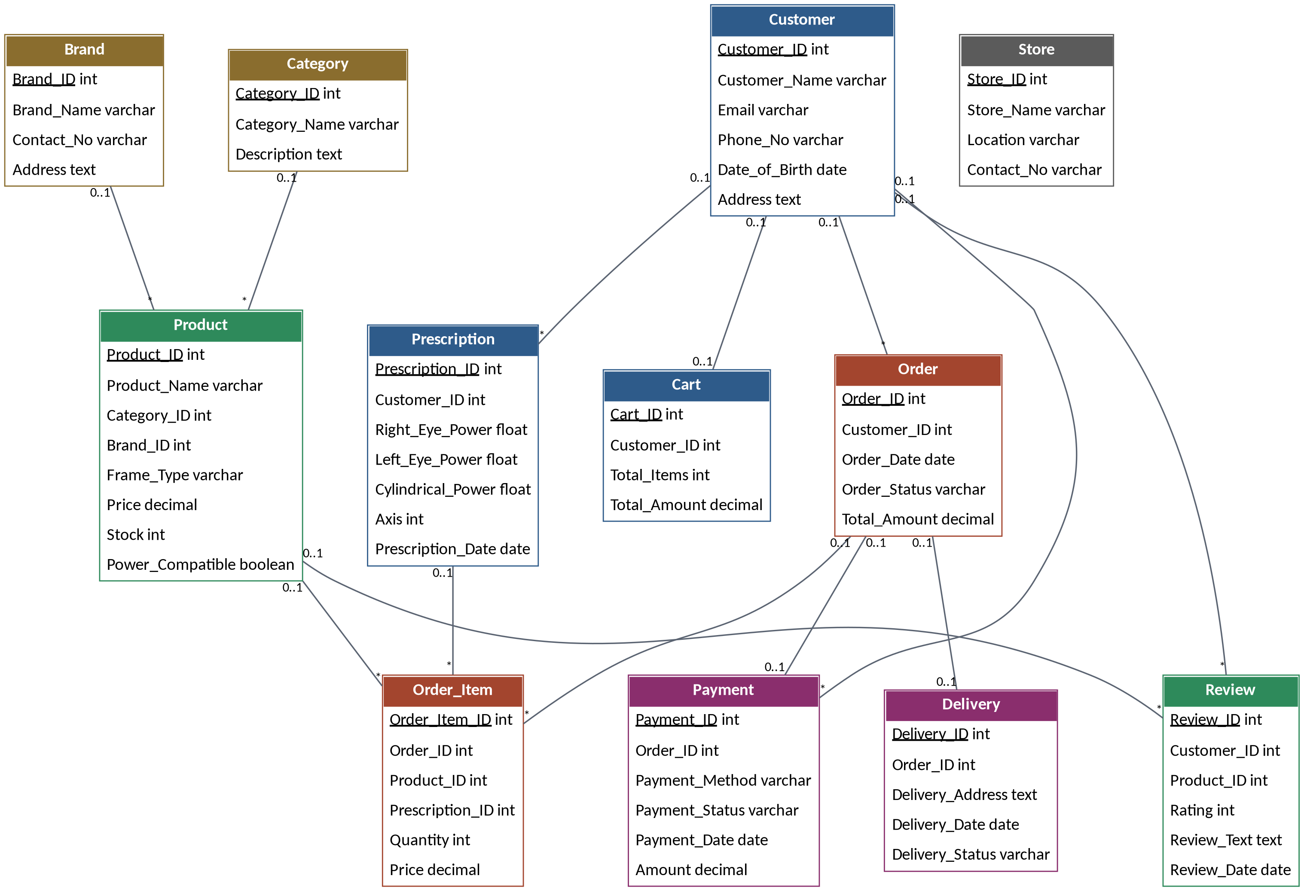

3.4 Overall ER Diagram
The table below summarizes the relationships between entities, along with their cardinality and participation constraints.
Entity 1 | Relation | Entity 2 | Cardinality | Participation
Customer | Owns | Cart | One-to-One | Partial / Total
Customer | Has | Prescription | One-to-Many | Partial / Total
Customer | Places | Order | One-to-Many | Partial / Total
Customer | Writes | Review | One-to-Many | Partial / Total
Category | Categorizes | Product | One-to-Many | Total / Partial
Brand | Belongs To | Product | One-to-Many | Partial / Total
Supplier | Supplies | Product | One-to-Many | Partial / Total
Order | Contains | Order_Item | One-to-Many | Total / Total
Product | Included In | Order_Item | One-to-Many | Partial / Total
Order | Generates | Payment | One-to-Many | Total / Total
Order | Generates | Delivery | One-to-Many | Total / Total
Product | Receives | Review | One-to-Many | Partial / Total
Store | Sells | Product | One-to-Many | Partial / Partial
